Metallogenesis of the Lachlan Orocline: is the mineral wealth of southeast Australia due to the accretion of VanDieland?

David Huston¹, Ross Cayley² and David Champion¹
¹Geoscience Australia, GPO Box 378, Canberra, ACT 2601
²Geological Survey of Victoria,
Keywords. Lachlan Orocline, metallogenesis, southeastern Australia

Abstract
The period between 480 Ma and 410 Ma in the Lachlan Orogen of southeastern Australia is the most important metallogenically in eastern Australia, having contributed over half of the mineral wealth in the Tasman Element (or Orogen). The period of intense mineralisation is interpreted to be related to the development of the Lachlan Orocline at the very end of the Ordovician and into the Silurian. Formation of this orocline was triggered by the oblique accretion of the VanDieland crustal fragment, which includes the present day Melbourne Zone in Victoria and western Tasmania. Prior to this event, eastern Australia was characterised by a west-dipping convergent margin with associated small- to moderate-sized volcanic-hosted massive sulphide (VHMS: Girilambone, Mount Windsor and Balcooma) and calc-alkaline porphyry Cu-Au deposits (Copper Hill, Marsden) with ages of 480 Ma to 450 Ma. Orocline development was initiated by the accretion of the VanDieland at ~445 Ma, which was accompanied orogenic gold mineralisation in Victoria (Bendigo, Ballarat, etc). Importantly, because of the geometry of interaction, gold mineralisation did not extend into present-day New South Wales. As accretion of this block continued, the Tasman continental margin began to wrap around VanDieland to form the Lachlan Orocline. At this time, extension associated with orocline formation to the north initiated low degree partial melting and post-collisional alkaline magmatism. Alkaline porphyry Cu-Au deposits in the Macquarie volcanic province (Cadia and Northparkes) formed during this extension at ~435 Ma. Continued extension and the re-establishment of west-dipping subduction in the Silurian saw a second phase of VHMS mineralisation at 425-415 Ma, and granite-related Sn and Mo mineralisation at 430-410 Ma. The concept of the Lachlan Orocline can be used to identify new areas of mineral potential and the extension of known areas undercover.

Introduction
Since the broad acceptance of the plate tectonic paradigm by the geoscientific community in the 1960s and 1970s, it has become increasingly apparent that mineral deposits form as a consequence of tectonic processes and events, and, moreover, that the character of mineral deposits changes as a tectonic system evolves. For example, Sillitoe (1972) and Hutchinson (1973) recognised that porphyry copper and volcanic-hosted massive sulphide (VHMS) deposits formed along convergent margins, and Sawkins (1984) argued convincingly that most types of mineral deposit form in specific tectonic settings. As the understanding of the evolution of tectonic systems has progressed, it has also become apparent that the types of mineral deposits change as tectonic systems evolve (Kerrich et al., 2000, 2005; Huston et al., in press). For example, in many well studied major mineral provinces around the world (e.g. Eastern Goldfields and Lachlan in Australia) VHMS deposits form early in the evolution of convergent margins, during back-arc extension associated with slab roll-back, whereas orogenic gold deposits form much later, commonly during contraction towards the end of the tectonic cycle (Huston et al., in press). Not only is there a temporal distribution of ore deposit types, but, in some cases, the character of mineral deposits vary spatially within a given tectonic system. The temporal and spatial variation of mineral deposits within tectonic systems has the potential to predict areas of mineral potential, particularly if the tectonic system is well understood.
Cayley (2012) and Cayley and Musgrave (this volume) have developed a new model for the Ordovician to Silurian evolution of the Lachlan Orogen (Fig. 1) in southeast Australia. Based upon geophysical data and regional field relationships they proposed that, during the late Ordovician to earliest Silurian, a moderate sized cratonic block - VanDieland, comprising the Melbourne Zone in Victoria and the western two-thirds of Tasmania - was accreted onto the Tasman convergent margin. This triggered the formation of an orocline, the Lachlan Orocline, the fundamental geological building block in southeastern Australia.
The Ordovician to Silurian in southeastern Australia is among the richest epochs in Australia for mineral wealth. This period produced the porphyry copper-gold deposits of the Macquarie volcanic province and the majority of gold in the Victorian goldfields as well as smaller VHMS and granite-related tin and molybdenum deposits. Ordovician to Silurian deposits in the Lachlan Orogen include approximately 52% of the global metallic mineral wealth of the Tasman Element (based on production and resource data and prices from Huston et al., 2012), the eastern third of the Australian continent.
In the following discussion we use the known spatial (Fig. 1) and temporal (Fig. 2) distribution of mineral deposits, along with the modelled formation of the Lachlan Orocline (e.g., Moresi et al., 2014), to develop a tectono-metallogenic model to explain the metallogeny of southeast Australia. These results are then used to predict, in broad terms, areas of mineral potential.

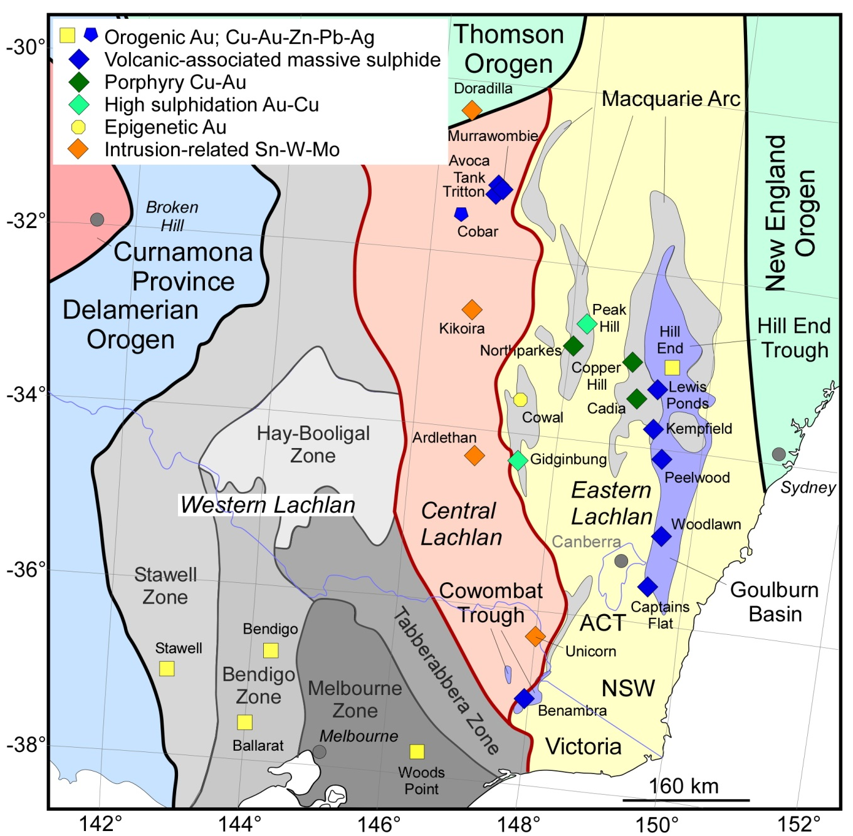

Figure 1 Map showing the distribution of tectonic elements (from Glen, 2013 and Champion et al., 2009), the distributions of the Macquarie Volcanic Province, Hill End Trough, Goulburn Basin and Cowombat Trough, and major mineral deposits of southeastern mainland Australia.

Spatial and temporal distribution of Ordovician to Silurian mineral deposits in the Lachlan Orogen
As shown by Figures 1 and 2, the spatial and temporal distribution of major mineral deposits in southeastern Australia is characterised by relatively systematic patterns, particularly in the interval between 480 Ma and 410 Ma. As an example, Benambran-aged (i.e., ~445 Ma) orogenic gold deposits are restricted to western and central Victoria, whereas ~435 Ma porphyry Cu-Au and related deposits are restricted to north-central New South Wales. ~480 Ma VHMS deposits are restricted to central New South Wales, west of the porphyry Cu-Au belt, whereas ~420 Ma VHMS deposits form a belt that extends from east-central New South Wales southwards into northeast Victoria. Granite-related Sn and Mo deposits of many different ages form a north-south-trending belt in west-central New South Wales that extends into northern Victoria (Fig. 1: the Omeo-Wagga tin belt). As discussed before, there are also temporal trends in deposit types, as shown in Figure 2. This is best illustrated by VHMS and orogenic gold deposits, with the former forming early in tectonic cycles and the latter associated with orogenies toward the end of tectonic cycles. Granite-related deposits also seem to form towards the end of tectonic cycles (Fig. 2).

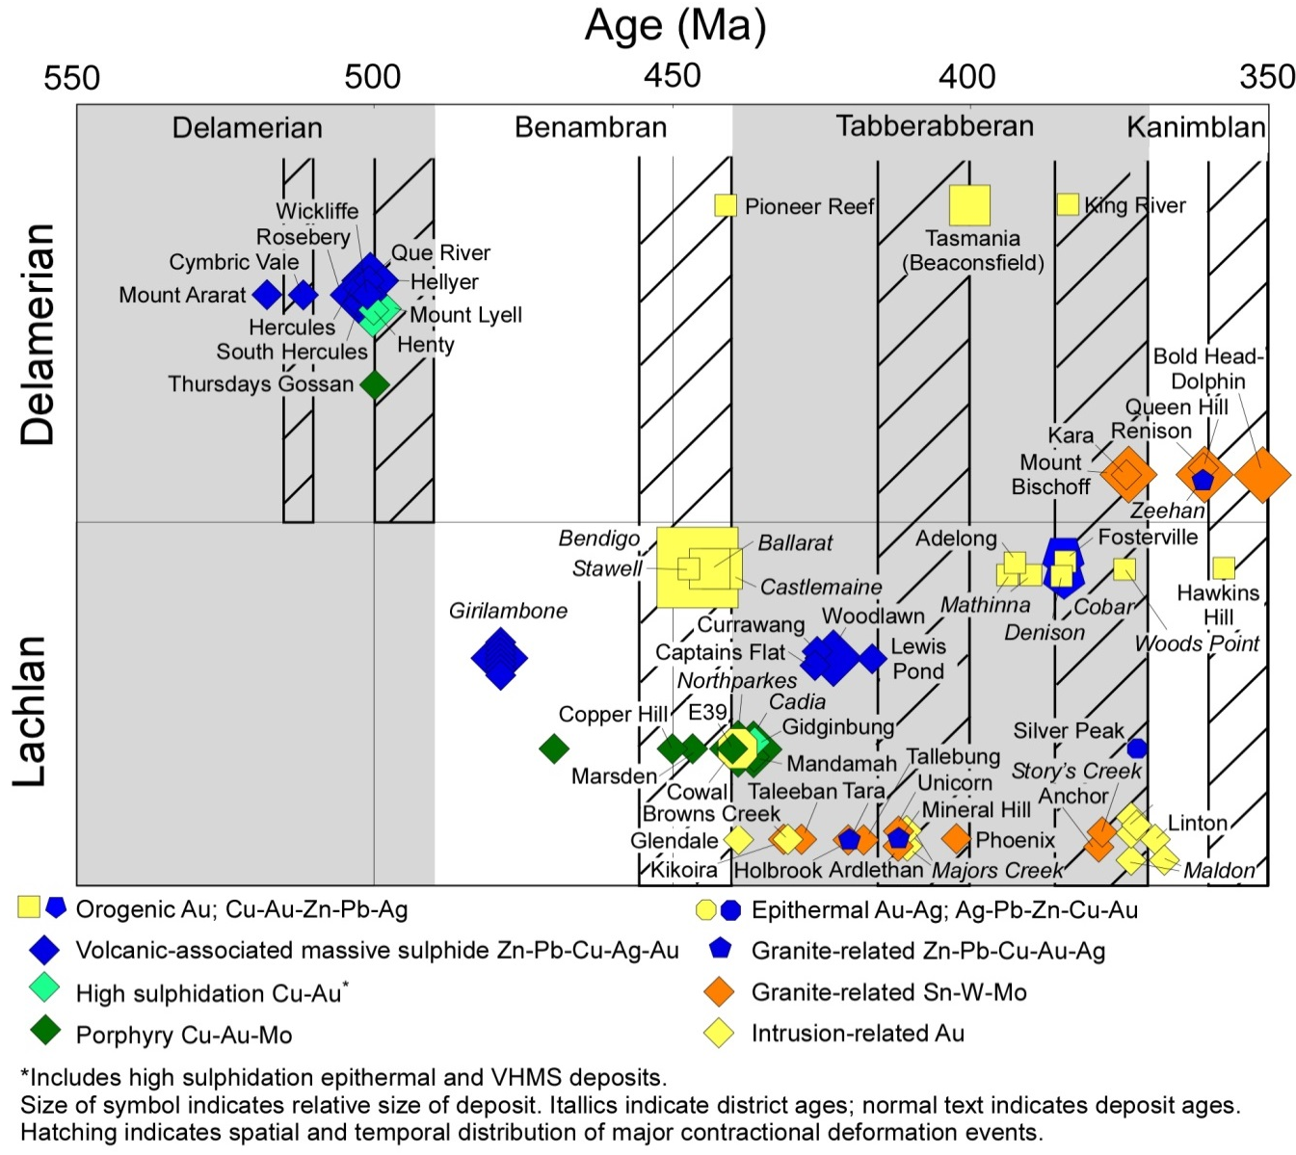

Figure 2 Space-time diagram showing the age and relationship of mineralising events to orogenic cycles of the Tasman Element. Updated from Champion et al. (2009)

An important development in the understanding of the metallogenesis of southeastern Australia has been the realisation that the ages of orogenic gold deposits in Victoria may be resolved from the ages of porphyry Cu-Au deposits in central New South Wales. Age differences between these two deposit types were not resolvable a few years ago, but critical analysis of Victorian goldfield ages by Phillips et al. (2012) and an improvement in the ages of the New South Wales suggest (although do not prove) resolution into two temporally separate events. This resolution appears not only to have solved the apparent conundrum of coeval orogenic gold and porphyry Cu-Au deposits, but also provides important constraints on the tectono-metallogenic evolution of the Lachlan Orogen.
Another important constraint on the tectono-metallogenic evolution of the Lachlan Orogen is the recognition of two groups of porphyry Cu-Au deposits in the Macquarie volcanic province. Work by Crawford et al. (2007) and Cooke et al. (2007) indicated that the main porphyry Cu-Au (e.g. Cadia Valley deposits and Northparkes) and related deposits in this province are associated with alkaline magmatism and formed at ~435 Ma. In addition, a smaller set of older (~450 Ma and older: Copper Hill and Marsden) deposits was recognised associated with calc-alkaline magmatism (see also Champion et al., 2009). Crawford et al. (2007) interpreted the geochemistry of granites associated with the ~435 Ma deposits to suggest that these deposits formed post-collisional, and interpretation consistent with that of alkaline-related porphyry Cu deposits worldwide (Richards, 2009). In contrast, older porphyry Cu-Au deposits are more typical of those formed during arc formation.

The Lachlan tectono-metallogenic system
These changes in metallogenic patterns can be linked to the development of the Lachlan Orocline, which perturbed convergence along the eastern margin of Australia at the very end of the Ordovician during the Benambran Orogeny (Cayley and Musgrave, this volume).
During the Ordovician and Silurian, the tectonic evolution of eastern Australia was complex and apparently contradictory leading to a variety of tectonic models being proposed (see review by Champion et al., 2009). However, the coverage of southeastern Australia by high-quality aeromagnetic data and new methods of processing such data, along with new geological data from modern regional geological mapping programs and insights from geodynamic modelling (Moresi et al., 2014), have led Cayley (2012) and Cayley and Musgrave (this volume) to propose a tectonic model in which the accretion of the exotic VanDieland (or Taswegia: Gibson et al., 2011) continental fragment, which comprises most of Tasmania and the Selwyn Block (Cayley et al., 2002), onto the Tasman convergent margin caused the formation of an orocline. Lachlan Orocline formation involved parts of the subduction zone adjacent to the site of microcontinent accretion rolling-back asymmetrically throughout the Silurian, eventually wrapping and translating parts of the Lachlan Orogen around the outer margins of VanDieland. A simple, continent dipping subduction zone re-established farther outboard in the Early Devonian (Fig. 3). In the following discussion, the metallogeny of southeastern Australia in discussed in the context of this tectonic event, which we term the Lachlan tectono-metallogenic event. The resulting metallogenic model is then used to infer zones of higher metallogenic potential that are the consequence of the Lachlan event (see below).
The evolution of this tectonic system explains the known spatial and temporal distribution of mineral deposits (systems) from 480 Ma to 410 Ma in eastern Australia. Prior to the impact of VanDieland at ~445 Ma, convergence along the eastern margin of mainland Australia was characterised by the presence of an arc-back-arc system on the over-riding Australian plate. This system developed in response to the oblique (from present-day southeast) subduction of a proto- Pacific plate that contained the microplate VanDieland. During this period of subduction, VHMS deposits formed in back-arc basins in north-central New South Wales (e.g., Tritton: Fig. 3A) and northern Queensland (e.g., Thalanga and Balcooma; not shown in Fig. 3A), and calc-alkaline porphyry Cu-Au deposits (e.g., Copper Hill and Marsden) formed during the early stages of the Macquarie volcanic province (at this time an arc).
The impact of VanDieland (Fig. 3B) caused orogenesis, the Benambran Orogeny, in the immediate hinterland (e.g., central and western Victoria), with the associated development of an orogenic gold mineral system (Victorian goldfields: Squire and Miller, 2003) that did not extend to the north into what is now New South Wales. Collision also initiated extension directly to the north along strike, leading to the formation of an orocline as mainland Australia partly enveloped VanDieland (Figs. 3B-C). With the mainland Australian plate to the north in extension (Moresi et al., 2014: Fig. 3C) low degree partial melting of the underlying mantle produced alkaline magmatism and porphyry Cu-Au mineral systems (e.g., Cadia and Northparkes) in the Macquarie volcanic province (at this time in post-collisional extension and not an arc). Subduction continued to roll-back into the Late Silurian, causing extension and forming post-orogenic granite-related Sn and Mo deposits (430-420 Ma) and then VHMS deposits (~420 Ma: Fig. 3D), after which steady-state subduction was re-established.
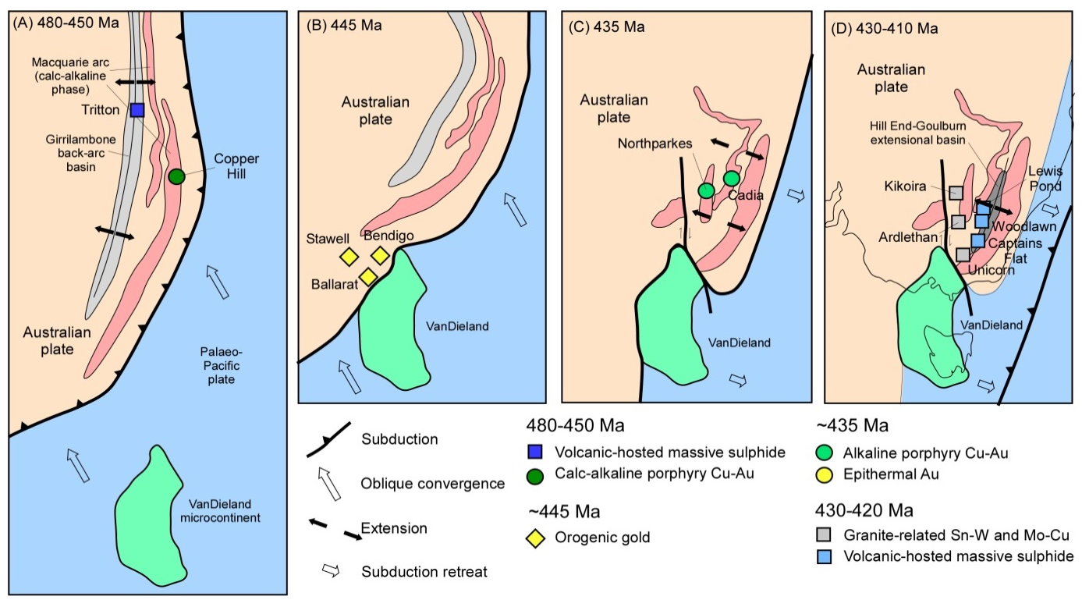

Figure 3 Inferred evolution of the Lachlan tectono-metallogenic system (adapted from Moresi et al., 2014): (A) oblique subduction and approach of VanDieland (480-450 Ma), (B) accretion of VanDieland and the Benambran Orogeny (445 Ma), (C) formation of Benambran orocline (~435 Ma), and (D) subduction retreat and re-establishment of oblique subduction (430-410 Ma). The locations of significant deposits are shown as they formed during the evolution of the Benambran tectono-metallogenic system

Implications for exploration
The Lachlan tectono-metallogenic system evolved over a period of 70 million years, producing a range of deposit types and a large proportion of eastern Australia's mineral wealth. The development of a tectono-metallogenic model for the Lachlan event can be used predictively to assess potential mineral system plays in southeastern Australia. As discussed above, the Lachlan Orocline model explains much of the known metallogenesis of southeastern Australia. However, the Lachlan Orogen is extensively covered by younger basins, with less than 50% exposed, and much of the exposed area has extensive regolith development. Both of these factors hinder exploration.
Consideration of each stage of the the Lachlan Orocline development yields conceptual exploration targets both in exposed and under cover terranes. For example, the geometry of the tectonic system suggests that 480-450 Ma porphyry Cu-Au and VHMS mineral systems would have been present along much of the Tasmanides, extending from northern Queensland to Victoria. Areas highlighted by this analysis include extensions of the Macquarie volcanic province northward under the Sydney-Gunnedah Basin and the Hay-Booligal Zone under the Murray Basin (Fig. 4). In addition, potential for VHMS deposits may extend south from the Girrilambone district, which includes the Tritton deposit, along the eastern margin of the Central Lachlan Subprovince.

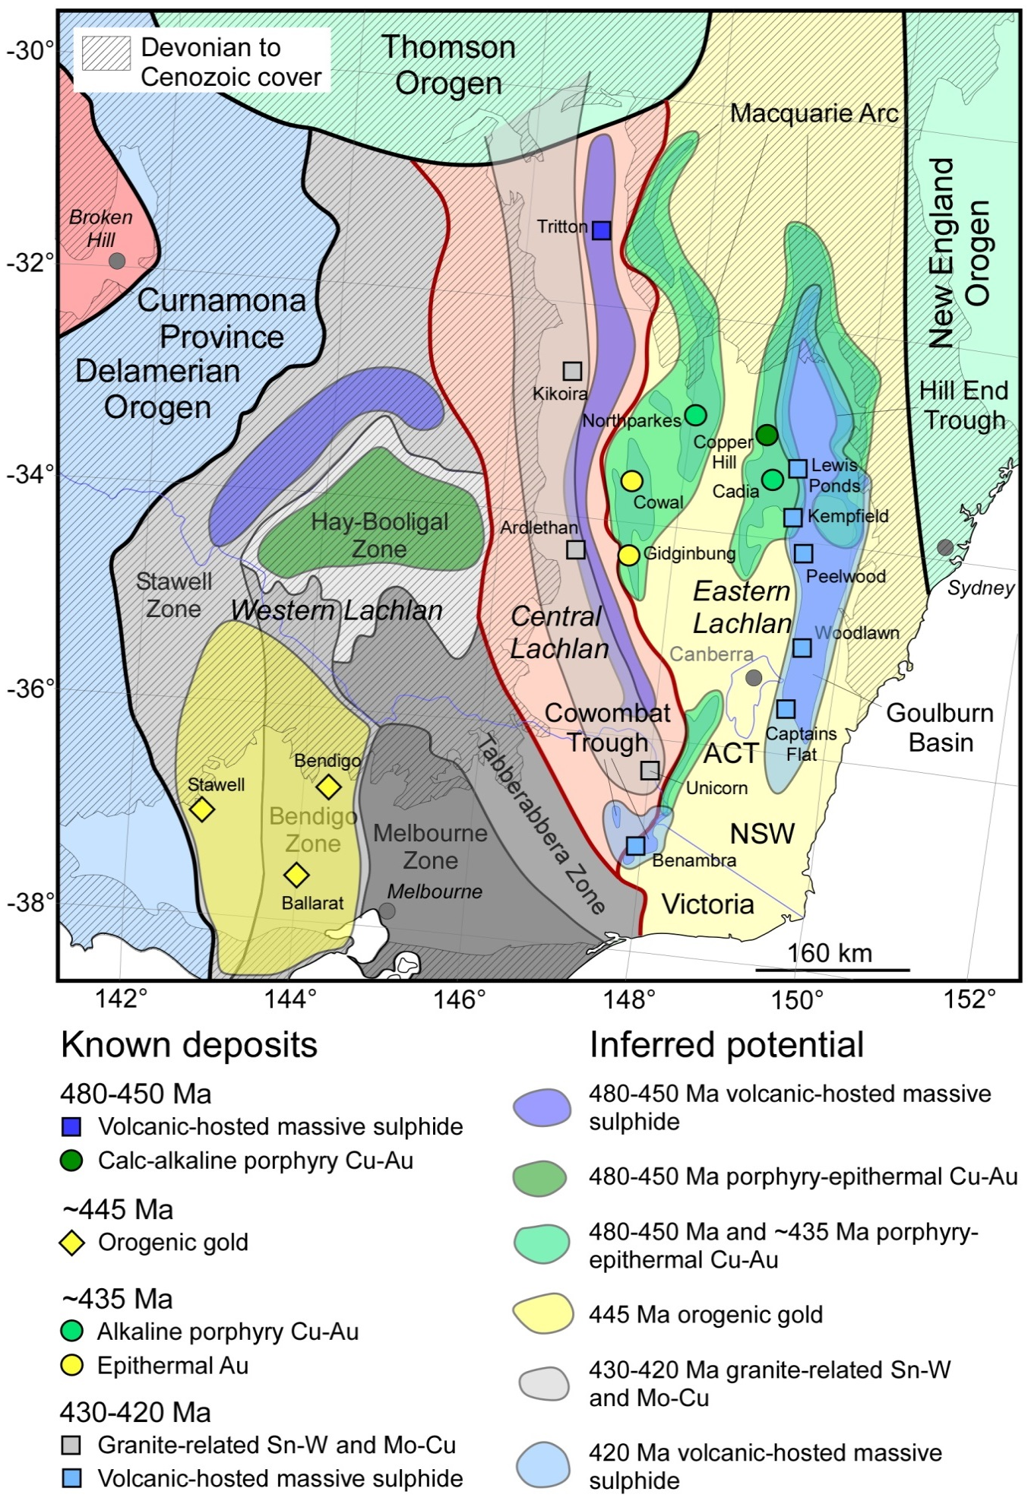Figure 4 Known and inferred mineral potential associated with Lachlan orocline formation in southeastern Australia. Geological provinces from Glen (2013); overlay of Devonian to Cenozoic cover is from Geoscience Australia databases

The model also suggests that orogenic gold mineralisation associated with the ~445 Ma Benambran Orogeny should be restricted to the hinterland of the VanDieland impactor, that
is, south of the Murray River. This mineralisation should extend north and south under the Murray and Otway basins, with extensions under the Murray Basin indicated by the relatively recent discoveries at Tandarra and Four Eagles prospects (http://www.catalystmetals.com.au) north of Bendigo.
In contrast, deposits related to the Lachlan Orocline (i.e., alkaline porphyry Cu-Au, 425-415 Ma VHMS and 430-410 Ma granite related deposits) will mostly be restricted to New South Wales, in the northern extensional zone modelled by Moresi et al. (2014). Potential for these deposits extends north under the Sydney-Gunnedah Basin. Given their association with post-orogenic extension (Hayward and Skirrow, 2010), iron oxide copper-gold (IOCG) deposits may also be present in this area.

Conclusions
Major mineralisaing events are commonly the consequence of local- or global-scale tectonic events. Major mineral districts in southeastern Australia, including the Victorian goldfields and the Macquarie copper-gold province, may be a response to the oblique accretion of the VanDieland microcontinent, which initiated the Benambran Orogeny, and the development of the Lachlan Orocline. Prior to this event, mineralisation along the Tasman convergent margin was dominated by small- to moderate-sized, 480-450 Ma, VHMS and calc-alkaline porphyry copper deposits. Accretion of VanDieland caused orogenic gold mineralisation in the ~445 Ma Victoria goldfields, and extension associated with orocline formation caused alkaline porphyry and related mineralisation in the ~435 Ma Macquarie copper-gold province. Continued extension amd re-establishment of steady-stage convergence caused granite-related tin and molybdenum and renewed VHMS mineralisation.
The Lachlan Orocline tectono-metallogenic model not only predicts known mineral provinces in southeastern Australia, but predicts the extension of these provinces under cover and new provinces. Undercover areas highlighted include: (1) the Hay-Booligal Zone under the Murray Basin for VHMS and calc-alkaline porphyry copper-gold mineralisation, (2) extensions of the Victorian goldfields below the Otway and Murray basins, and (3) extensions of the Macquarie copper-gold province and the Silurian VHMS province underneath the Sydney-Gunnedah Basin. The model also highlights VHMS potential along the eastern margin of the poorly exposed Central Lachlan Subprovince, and possible IOCG potential in extensional zones associated with Lachlan Orocline formation.

References
Cayley, R.A. 2012, Oroclinal folding in the Lachlan Fold Belt: consequence of southeast-directed Siluro-Devonian subduction rollback superimposed on an accreted Ordovician arc assemblage in eastern Australia, Geological Society of Australia Abstracts, 103: 34–43
Cayley R.A., and Musgrave, R. this volume, The Giant Lachlan Orocline – A powerful new predictive tool for mineral exploration under cover across Eastern Australia
Cayley, R.A., Taylor, D.H., VandenBerg, A.H.M., and Moore, D.H. 2002, Proterozoic–Early Palaeozoic rocks and the Tyennan Orogeny in central Victoria: the Selwyn Block and its tectonic implications. Australian Journal of Earth Sciences, 49: 225–254
Champion, D.C., Kositcin, N., Huston, D.L., Mathews, E., and Brown, C. 2009, Geodynamic synthesis of the Phanerozoic of eastern Australia and implications for metallogeny. Geoscience Australia Record 2009/18, 254 p.
Cooke, D.R., Wilson, A.J., House, M.J., Wolfe, R.C., Walshe, J.L, Lickfold, V., and Crawford, A.J. 2007, Alkalic porphyry Au – Cu and associated mineral deposits of the Ordovician to Early Silurian Macquarie Arc, New South Wales, Australian Journal of Earth Sciences, 54, 445-463.
Crawford, A.J., Meffre, S., Squire, R.J., Barron, L.M., and Falloon, T.J. 2007, Middle and Late Ordovician magmatic evolution of the Macquarie Arc, Lachlan Orogen, New South Wales. Australian Journal of Earth Sciences, 54: 181-214.
Gibson, G.M., Morse, M.P., Ireland, T.R., and Nayak, G.K. 2011, Arc–continent collision and orogenesis in western Tasmanides: Insights from reactivated basement structures and formation of an ocean–continent transform boundary off western Tasmania, Gondwana Research, 19: 608-627
Glen, R.A. 2013, Refining accretionary orogen models for the Tasmanides of eastern Australia, Australian Journal of Earth Sciences, 60: 315–370.
Hayward, N., and Skirrow, R.G. 2010, Geodynamic setting and controls on iron oxide Cu-Au(±U) ore in the Gawler Craton, South Australia, in: Porter, T.M., (Ed.), Hydrothermal iron oxide copper-gold and related deposits: A global perspective, Volume 3, Advances in the understanding of IOCG deposits, PGC Publishing, Adelaide, 105-131.
Huston, D.L., Skirrow, R.G., Blewett, R.S., Wang, J., Jaques, A.L. and Waters, D. 2012, , in Blewett, R. (Ed.),. Shaping a nation: A geology of Australia. Geoscience Australia, Canberra, 381-432.
Huston, D.L., Mernagh, T.P., Hagemann, S.G., Doublier, M.P., Fiorentini, M., Chapion, D.C., Jacques, A.L., Czarnota, K., Cayley, R., Skirrow, R., and Basrakov, E. in press, Tectono-metallogenic systems - the place of mineral systems within tectonic evolution, with an emphasis on Australian examples, Ore Geology Reviews
Hutchinson, R.W. 1973, Volcanogenic massive sulfide deposits and their metallogenic significance, Economic Geology, 68: 1223-1246
Kerrich, R., Goldfarb, R.J., Groves, D.I., and Garwin, S. 2000, The geodynamics of world class ore deposits: characteristics, space-time distribution, and origins, Reviews in Economic Geology, 13: 501-551.
Kerrich, R., Goldfarb, R.J., and Richards, J.P., 2005. Metallogenic provinces in an evolving geodynamic framework, Economic Geology 100th Anniversary Volume, 1097-1139.
Moresi, L., Betts, P.G., Miller, M.S., and Cayley, R.A. 2014, Dynamics of continental accretion, Nature, 508: 245–248.
Phillips, D., Fu, B., Wilson, C.J.L., Kendrick, M.A., Fairmaid, A.M., and Miller, J.M. 2012, Timing of gold mineralisation in the western Lachlan Orogen, SE Australia: A critical overview, Australian Journal of Earth Sciences, 59: 495-525.
Richards, J.P. 2009, Postsubduction porphyry Cu-Au and epithermal Au deposits: products of remelting of subduction-modified lithosphere, Geology, 37: 247–250.
Sawkins, F.J. 1984, Metal deposits in relationship to plate tectonics. Berlin, Springer-Verlag, 325 p
Sillitoe, R.H. 1972, A plate tectonic model for the origin of porphyry copper deposits, Economic Geology, 67: 184-197
Squire, R.J., and Miller, J.M. 2003, Synchronous compression and extension in East Gondwana; tectonic controls on world-class gold deposits at 440 Ma, Geology, 31: 1073-1076

